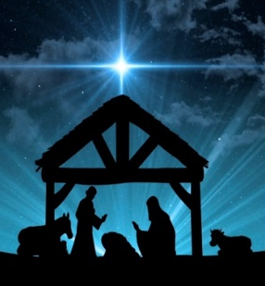
Let’s Get Ready for Jesus!
Saturday December 2, 2017
6 PM-9 PM

Reservation Form:

Reservations are required since we are limited to 50 children. Please RSVP by completing this form and mailing it to msm@stpatricktampa.org. We do need a few more adult leaders, high school group leaders and middle school assistants. Please let us know if you can volunteer.

Please Reserve a space for my child:

Name Age Grade Camper☐ MS/HS Leader☐

Name Age Grade Camper☐ MS/HS Leader☐

Name Age Grade Camper☐ MS/HS Leader☐

Name Age Grade Camper☐ MS/HS Leader☐

Thanks for asking! I would love to help. Please select below:
Registration☐ Food☐ Crafts☐ Room Leader☐ Team Leader☐
Name Phone

Email

Emergency Contact Name Phone

Food Allergies for any of the children

For all children, images of them may be used on parish electronic and printed media:
Yes ☐ No ☐

